Unit Testing with xUnit in C#

1. Learning Outcomes
- Understand the purpose of unit testing in professional C# development.
- Distinguish clearly between the main project and the test project.
- Know exactly where each code file should be written in Visual Studio.
- Understand what happens during test execution.
- Use [Fact] for single fixed test cases and [Theory] for parameterized test cases.
- Write complete xUnit-based test programs for mathematical, string, and validation scenarios.

2. Why Unit Testing Matters
Unit testing verifies that small units of code, usually methods, produce the expected result. Instead of checking correctness manually after every change, the developer writes automated tests. When the tests are run, the testing framework compares the actual result with the expected result and reports whether the code passed or failed.
- It detects logic errors early.
- It makes maintenance and refactoring safer.
- It increases confidence before integration and deployment.
- It encourages writing clear, modular, reusable code.

3. Where Exactly Is Each Code Written?
Students often ask where the method code should be written and where the test code should be written. In unit testing, the application logic and the test logic are separated into two different projects inside one solution.
Part | Purpose
Solution | Container that holds both projects together in one Visual Studio solution.
Main Project (Class Library) | Contains the real application code, such as classes and methods like Add, Divide, Reverse, and ValidateAge.
Test Project (xUnit Test Project) | Contains only test classes and test methods that call the main project and verify its behavior.
Main method | Not required for this lecture. We are not using console interaction or manual program flow.

Important rule
The main project contains the real methods. The test project does not rewrite these methods. Instead, it creates objects from the main project, calls those methods, and checks whether the result is correct.

3.1 Typical file layout in Visual Studio
Solution: TestingLecture
│
├── Project 1: CalculatorApp (Class Library)
│ ├── MathOps.cs
│ ├── StringOps.cs
│ └── ValidationOps.cs
│
└── Project 2: CalculatorApp.Tests (xUnit Test Project)
├── MathOpsTests.cs
├── StringOpsTests.cs
└── ValidationOpsTests.cs
Each class in the main project can have a corresponding test class in the test project. This organization makes it easy to understand and makes large projects easier to maintain.

4. How to Create the Projects in Visual Studio
- Open Visual Studio and choose Create a new project.
- Create a Class Library project and name it CalculatorApp.
- Add a second project to the same solution and choose xUnit Test Project.
- Name the test project CalculatorApp.Tests.
- Right-click the test project, choose Add > Project Reference, then reference CalculatorApp.
- Write the main classes in CalculatorApp and write the tests in CalculatorApp.Tests.
- Open Test Explorer and run all tests.

5. What Happens During Execution?
Because this lecture does not use the console, execution does not start from Main. Instead, execution is controlled by the xUnit testing framework.
- Visual Studio or dotnet test discovers all test methods in the test project.
- xUnit identifies methods marked with [Fact] or [Theory].
- For each test method, xUnit creates the required objects and runs the code inside the test.
- The test calls a method from the main project.
- An assertion compares the actual result with the expected result.
- xUnit records the outcome as Passed or Failed and shows it in Test Explorer.
Execution idea
The developer does not execute the business logic manually. The testing framework executes test methods automatically, and each test method internally calls the business logic that needs to be verified.

5.1 Simple execution flow example
[Fact]
public void Add_TwoNumbers_ReturnsCorrectResult()
{
MathOps math = new MathOps(); // object created
int result = math.Add(2, 3); // method from main project is executed
Assert.Equal(5, result); // expected and actual values are compared
}
When this test runs, xUnit enters the test method, creates an object of MathOps, executes Add(2, 3), gets the value 5, and checks whether it matches the expected value. If the values are equal, the test passes.

6. The AAA Pattern
Most unit tests follow the AAA pattern: Arrange, Act, and Assert.
Arrange: Prepare the object, input values, and test data.
Act: Call the method that is being tested.
Assert: Verify the returned result or expected behavior.
[Fact]
public void Multiply_TwoNumbers_ReturnsCorrectProduct()
{
// Arrange
MathOps math = new MathOps();
// Act
int result = math.Multiply(4, 5);
// Assert
Assert.Equal(20, result);
}

7. Detailed Discussion of [Fact] and [Theory]

7.1 [Fact]
[Fact] is used when the test represents one fixed scenario. The input values are written directly inside the test method. This is appropriate when the programmer wants to validate one specific condition or one clearly defined behavior.
- A [Fact] method has no parameters.
- It is useful for simple or special-case tests.
- It is often used for exception tests, null checks, or one specific expected output.
[Fact]
public void Divide_ByZero_ThrowsException()
{
MathOps math = new MathOps();
Assert.Throws<DivideByZeroException>(() => math.Divide(10, 0));
}
This test is a fixed scenario. The input is always 10 and 0, and the expected behavior is always an exception. Therefore [Fact] is the correct choice.

7.2 [Theory]
[Theory] is used when the same logical test should run several times with different data values. Instead of copying the test method many times, the programmer writes one parameterized test and supplies multiple inputs.
- A [Theory] method usually has parameters.
- It is commonly combined with [InlineData].
- It reduces repetition and improves coverage because many inputs can be tested quickly.
[Theory]
[InlineData(2, 3, 5)]
[InlineData(10, 5, 15)]
[InlineData(-1, 1, 0)]
[InlineData(0, 0, 0)]
public void Add_MultipleCases_ReturnExpectedValue(int a, int b, int expected)
{
MathOps math = new MathOps();
int result = math.Add(a, b);
Assert.Equal(expected, result);
}
Here xUnit executes the same test four times. In each run, different values are passed to the method. This makes [Theory] highly effective when the logic is the same but the input data changes.

7.3 Comparison between [Fact] and [Theory]
Feature | [Fact] | [Theory]
Number of cases | One fixed case | Many cases
Parameters | Usually no parameters | Usually has parameters
Data source | Inside the method body | InlineData or other data sources
Best use | Single scenario or special condition | Repeated logic with different input values

8. Other Important Testing Concepts
Assertion: An assertion is the statement that checks whether the result is correct. Examples include Assert.Equal, Assert.True, Assert.False, Assert.Null, Assert.NotNull, and Assert.Throws.
Test isolation: Each test should be independent. A test must not depend on another test being executed before it.
Deterministic result: A test should produce the same result every time when the same input is used.
Naming convention: A professional test name often follows the pattern MethodName_Condition_ExpectedResult.
Coverage: A strong test suite covers normal cases, boundary cases, and error cases.

9. Complete Program 1 - Mathematical Operations
The following example shows a full mini-project with all the code needed in both the main project and the test project. This helps the student understand exactly what is written and where it is written.

9.1 File: MathOps.cs (write this in the main project CalculatorApp)
namespace CalculatorApp
{
public class MathOps
{
public int Add(int a, int b) => a + b;
public int Subtract(int a, int b) => a - b;
public int Multiply(int a, int b) => a * b;
public double Divide(double a, double b)
{
if (b == 0)
throw new DivideByZeroException("Division by zero is not allowed.");
return a / b;
}
public bool IsEven(int number) => number % 2 == 0;
public int Max(int a, int b) => (a > b) ? a : b;
}
}

9.2 File: MathOpsTests.cs (write this in the test project CalculatorApp.Tests)
using Xunit;
using CalculatorApp;
namespace CalculatorApp.Tests
{
public class MathOpsTests
{
[Fact]
public void Add_TwoPositiveNumbers_ReturnsCorrectSum()
{
MathOps math = new MathOps();
int result = math.Add(3, 4);
Assert.Equal(7, result);
}
[Fact]
public void Subtract_TwoNumbers_ReturnsCorrectDifference()
{
MathOps math = new MathOps();
int result = math.Subtract(10, 3);
Assert.Equal(7, result);
}
[Fact]
public void Multiply_TwoNumbers_ReturnsCorrectProduct()
{
MathOps math = new MathOps();
int result = math.Multiply(4, 5);
Assert.Equal(20, result);
}
[Fact]
public void Divide_ByZero_ThrowsException()
{
MathOps math = new MathOps();
Assert.Throws<DivideByZeroException>(() => math.Divide(10, 0));
}
[Fact]
public void IsEven_EvenNumber_ReturnsTrue()
{
MathOps math = new MathOps();
bool result = math.IsEven(8);
Assert.True(result);
}
[Theory]
[InlineData(9, 4, 9)]
[InlineData(3, 8, 8)]
[InlineData(-1, -7, -1)]
public void Max_MultipleInputs_ReturnsLargestValue(int a, int b, int expected)
{
MathOps math = new MathOps();
int result = math.Max(a, b);
Assert.Equal(expected, result);
}
}
}

9.3 What exactly happens when these tests run?
- xUnit discovers six test cases in MathOpsTests.
- For each test, xUnit enters the method and executes it independently.
- The test creates a MathOps object and calls one of its methods.
- The assertion compares the actual output with the expected output.
- If the values match, the test passes. If not, the test fails and xUnit shows a detailed message.

10. Complete Program 2 - String Operations

10.1 File: StringOps.cs (main project)
using System.Linq;
namespace CalculatorApp
{
public class StringOps
{
public string Reverse(string text)
{
return new string(text.Reverse().ToArray());
}
public int GetLength(string text)
{
return text.Length;
}
public bool IsNullOrEmpty(string text)
{
return string.IsNullOrEmpty(text);
}
}
}

10.2 File: StringOpsTests.cs (test project)
using Xunit;
using CalculatorApp;
namespace CalculatorApp.Tests
{
public class StringOpsTests
{
[Fact]
public void Reverse_NormalWord_ReturnsReversedWord()
{
StringOps ops = new StringOps();
string result = ops.Reverse("hello");
Assert.Equal("olleh", result);
}
[Theory]
[InlineData("A", 1)]
[InlineData("ChatGPT", 7)]
[InlineData("Unit Test", 9)]
public void GetLength_MultipleInputs_ReturnsCorrectLength(string text, int expected)
{
StringOps ops = new StringOps();
int result = ops.GetLength(text);
Assert.Equal(expected, result);
}
[Fact]
public void IsNullOrEmpty_EmptyString_ReturnsTrue()
{
StringOps ops = new StringOps();
bool result = ops.IsNullOrEmpty("");
Assert.True(result);
}
}
}
This example shows that unit testing is not limited to numbers. Any logic unit, including string processing, can be tested using the same structure: main class in the main project and assertions in the test project.

11. Complete Program 3 - Validation Logic

11.1 File: ValidationOps.cs (main project)
namespace CalculatorApp
{
public class ValidationOps
{
public bool IsAdult(int age)
{
return age >= 18;
}
public string GetGrade(int score)
{
if (score >= 90) return "A";
if (score >= 80) return "B";
if (score >= 70) return "C";
return "D";
}
}
}

11.2 File: ValidationOpsTests.cs (test project)
using Xunit;
using CalculatorApp;
namespace CalculatorApp.Tests
{
public class ValidationOpsTests
{
[Theory]
[InlineData(18, true)]
[InlineData(21, true)]
[InlineData(16, false)]
public void IsAdult_MultipleAges_ReturnsExpectedResult(int age, bool expected)
{
ValidationOps ops = new ValidationOps();
bool result = ops.IsAdult(age);
Assert.Equal(expected, result);
}
[Theory]
[InlineData(95, "A")]
[InlineData(84, "B")]
[InlineData(73, "C")]
[InlineData(60, "D")]
public void GetGrade_DifferentScores_ReturnExpectedGrade(int score, string expected)
{
ValidationOps ops = new ValidationOps();
string result = ops.GetGrade(score);
Assert.Equal(expected, result);
}
}
}
This program demonstrates decision-based logic. Tests verify that the correct branch of the code is executed according to the given input.

12. How the Student Runs the Tests
- Open the solution in Visual Studio.
- Build the solution if necessary.
- Open Test Explorer from the Test menu.
- Click Run All.
- Review the result for each test: Passed, Failed, or Not Run.
- If a test fails, read the expected value, the actual value, and the test name to identify the problem.
What the student should remember
The student does not enter values manually during execution. The input values are already written inside the test methods. When Run All is clicked, xUnit executes every test automatically.

13. Best Practices for Writing Good Tests
- Keep each test focused on one behavior.
- Choose clear test names.
- Test normal cases, boundary cases, and invalid cases.
- Avoid putting complex logic inside the test itself.
- Keep methods in the main project small and testable.
- Use [Theory] when many data combinations should be checked.

14. Lecture Summary
Unit testing in C# with xUnit is based on separation of concerns. The main project contains the real program logic, while the test project contains automated checks. [Fact] is suitable for one fixed test scenario, whereas [Theory] is suitable for repeated testing with different values. During execution, xUnit discovers the tests, runs them independently, and reports whether each method behaves correctly. By organizing files clearly and using complete examples, students can understand not only the code itself but also the full lifecycle of writing, executing, and interpreting tests.

15. Suggested Exercises
- Write a class that checks whether a number is prime and test it with [Theory].
- Write a class that calculates factorial and test normal and boundary cases.
- Write a class that validates email length or password length and test valid and invalid inputs.
- Create one [Fact] test that checks whether a method throws an exception for invalid input.

Visual Guide to Solution, Methods, and Test Explorer
This section adds visual Windows/Visual Studio explanations so students can see exactly where each code file is written, how the method is tested, and what appears in Test Explorer during execution.

1. Block Diagram of the Full Workflow

Detailed explanation:
- Solution: the top-level container in Visual Studio. It keeps all related projects together in one organized workspace.
- CalculatorApp: the main project. This is where the real C# methods are written, such as Add, Subtract, Divide, and other business logic methods.
- CalculatorApp.Tests: the test project. This is where xUnit test classes are written by using [Fact], [Theory], and assertions such as Assert.Equal or Assert.Throws.
- Test Explorer: the Visual Studio window used to discover tests, run them, and display passed or failed results.

2. What Is a Solution in Visual Studio?
In Windows with Visual Studio, a solution is the outer container that keeps your projects together. In this lecture, the solution contains one project for the actual code and one project for the tests.
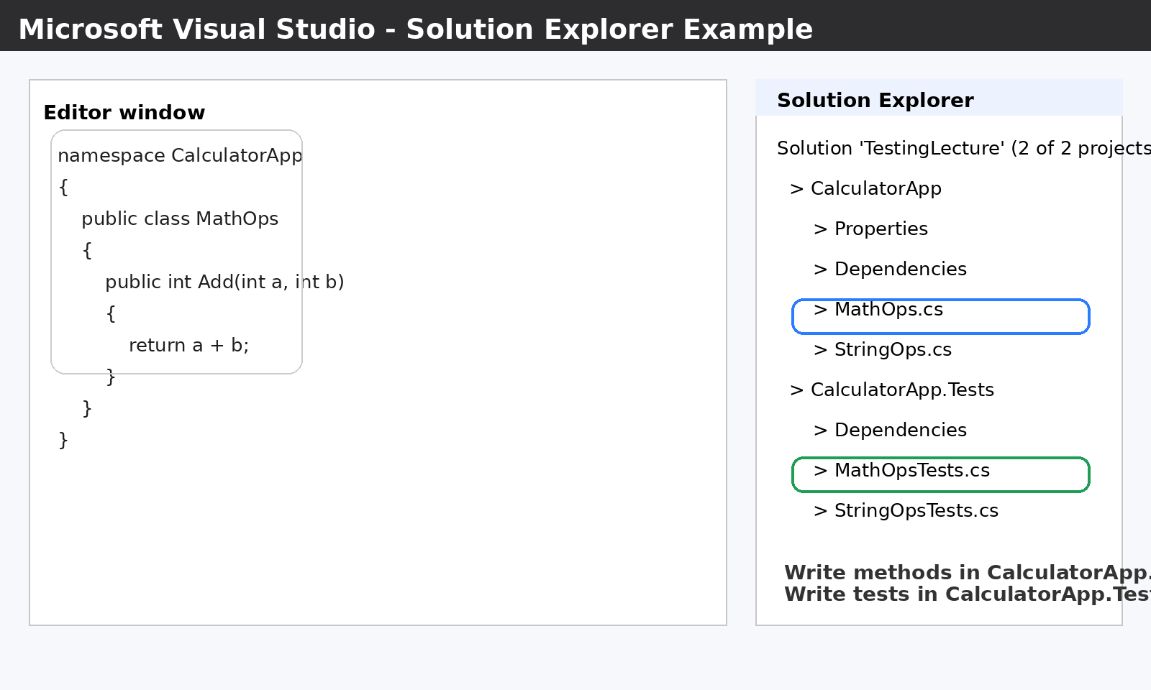
Figure 2. Example of the Solution Explorer in Visual Studio. The method files are written in the main project, while the test files are written in the test project.

Where is each code written?
Location in Visual Studio | What is written there | Why
CalculatorApp project | Normal C# classes and methods such as MathOps.cs, StringOps.cs, ValidationOps.cs | This is the real program logic that will be tested.
CalculatorApp.Tests project | Test classes such as MathOpsTests.cs and StringOpsTests.cs | This project checks whether the methods behave correctly.
Test Explorer window | No code is written here; it is only used to run and inspect the tests | It shows whether tests passed or failed after execution.

3. Detailed Example of a Method and Its Test (Lecture Summary)
The best way to understand unit testing is to follow one complete example. Below, the Add method is written in the main project, and then a test is written in the test project.

Step 1: Write the method in the main project file MathOps.cs.
namespace CalculatorApp
{
public class MathOps
{
public int Add(int a, int b)
{
return a + b;
}
}
}
Discussion of the method: this class belongs to the main project because it performs the actual computation. The method receives two integers, adds them, and returns the result. No test code and no user interface code are written inside this file.

Step 2: Write the test in the test project file MathOpsTests.cs.
using Xunit;
using CalculatorApp;
namespace CalculatorApp.Tests
{
public class MathOpsTests
{
[Fact]
public void Add_TwoPositiveNumbers_ReturnsCorrectSum()
{
var math = new MathOps();
int result = math.Add(2, 3);
Assert.Equal(5, result);
}
}
}

Discussion of the test method:
- using Xunit; imports the xUnit framework.
- using CalculatorApp; allows the test project to access the method class written in the main project.
- [Fact] marks this method as a single test case with fixed input values.
- var math = new MathOps(); creates an object from the class that contains the real method.
- math.Add(2, 3) executes the method under test.
- Assert.Equal(5, result) checks whether the returned value is exactly what is expected.

What happens when this test runs?
- Visual Studio discovers the test because it has the [Fact] attribute.
- The test framework creates the test execution environment automatically.
- The code inside the test method runs from top to bottom.
- The Add method is called with fixed values 2 and 3.
- If the method returns 5, the test passes. If it returns any other value, the test fails.

4. Detailed Discussion of [Fact] and [Theory]
[Fact] and [Theory] are both xUnit attributes, but they are used for different testing situations.

4.1 [Fact]
[Fact] is used when the test has one fixed scenario. It is suitable when you want to verify one specific case.
[Fact]
public void IsEven_Eight_ReturnsTrue()
{
var math = new MathOps();
bool result = math.IsEven(8);
Assert.True(result);
}
In this test, the input is fixed at 8. Therefore, [Fact] is the correct choice.

4.2 [Theory]
[Theory] is used when the same test logic must run with multiple input values. Instead of writing many separate [Fact] methods, you can write one parameterized test.
[Theory]
[InlineData(2, 3, 5)]
[InlineData(10, 4, 14)]
[InlineData(-1, 1, 0)]
public void Add_ManyCases_ReturnsExpectedSum(int a, int b, int expected)
{
var math = new MathOps();
int result = math.Add(a, b);
Assert.Equal(expected, result);
}
Here, xUnit executes the same test three times, once for each InlineData row. This makes [Theory] ideal for repeated validation with different values.

Key difference:
Attribute | Best use | Execution style
[Fact] | One fixed scenario | Runs one time
[Theory] | Many input values for the same logic | Runs once for each data row

5. Test Explorer in Visual Studio
Test Explorer is the Visual Studio window that detects all tests in the solution and runs them. It is especially important for students because it replaces the traditional idea of running Main() in a console application.
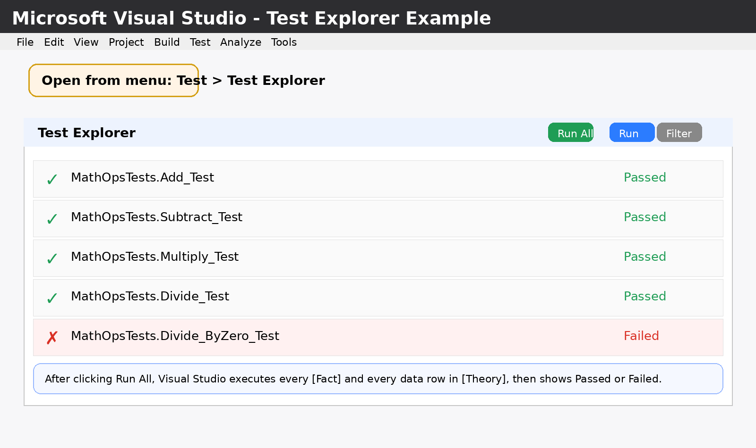
Figure 3. Example of Test Explorer showing the Run All button and the pass/fail status of tests.

How to open Test Explorer in Windows Visual Studio:
- Open the solution in Visual Studio.
- From the top menu, click Test.
- Choose Test Explorer.
- The Test Explorer window appears and lists all discovered tests.

What does Run All do?
- It executes every [Fact] test in the test project.
- It executes every [Theory] test once for each InlineData row.
- It compares actual output with expected output through assertions.
- It reports the final status of each test as Passed or Failed.

Detailed interpretation of the Test Explorer interface:
- Green check mark: the test passed. The method returned the expected result.
- Red cross mark: the test failed. The result did not match the expected value, or an unexpected exception occurred.
- Run All: executes all tests in the visible solution.
- Filter: narrows the test list if the solution contains many tests.
- Test name: usually follows a descriptive naming style such as Method_Condition_ExpectedResult.

Example of a failure message:
Assert.Equal() Failure
Expected: 6
Actual: 5
This means the method returned 5 but the test expected 6. Therefore, the logic or the expected value must be reviewed.

6. Windows / Visual Studio Interface Steps for Students
The following sequence can be followed exactly in the lab:
Step | Action in interface | Purpose
1 | Create the solution | Open Visual Studio, choose Create a new project, and create the first project. Visual Studio places it inside a solution.
2 | Create the main project | Choose Class Library (.NET). Name it CalculatorApp.
3 | Create the test project | Add a new project to the same solution and choose xUnit Test Project. Name it CalculatorApp.Tests.
4 | Add project reference | Right-click CalculatorApp.Tests, choose Add > Project Reference, and select CalculatorApp.
5 | Write method files | In CalculatorApp, create MathOps.cs and write the methods.
6 | Write test files | In CalculatorApp.Tests, create MathOpsTests.cs and write [Fact] or [Theory] methods.
7 | Open Test Explorer | From the Visual Studio top menu choose Test > Test Explorer.
8 | Run all tests | Click Run All and inspect the result of each test.

7. Final Teaching Summary
A solution is the overall Visual Studio container. The main project holds the real methods. The test project holds xUnit tests. Test Explorer is the execution window that runs tests and reports whether they passed or failed. Students should understand that, in unit testing, they do not run the program through console input; instead, they run tests through Test Explorer, and the framework automatically evaluates correctness.

